Use your web browser to go to http://winscp.net/eng/download.php and download the latest version "Installation package". Then Install it using the defaults.

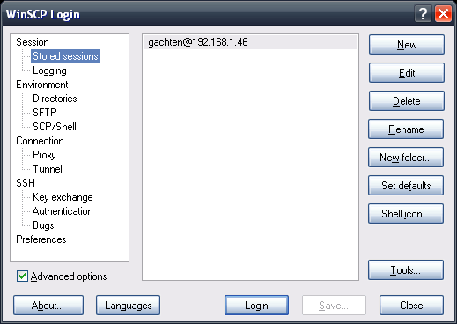
After installing start WinSCP and create a new Stored Session by clicking “Stored Sessions” on the top left of the above screenshot and then clicking “New” on the top right

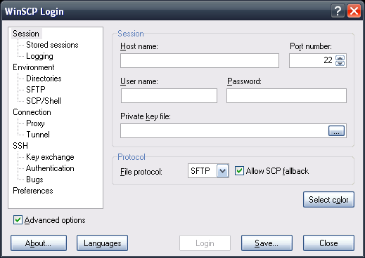
Use the information provided to you by TALHO to create a stored session
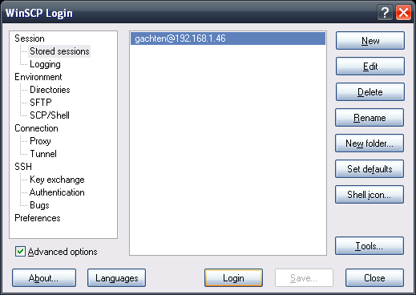#
Connect to that session by selecting the stored session and then clicking “Login” button at the bottom

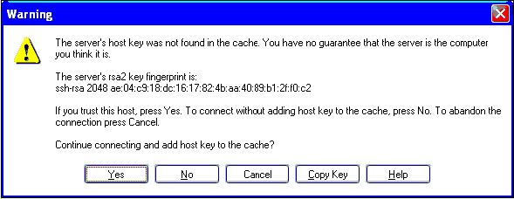
The FIRST time you connect you will be asked to accept the RSA KEY – click the “YES” button

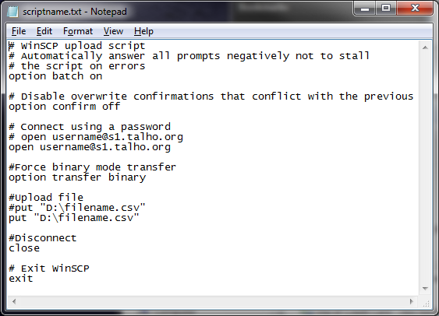
Edit the file and change the "username" and "filename" to match the ones you will be using

After successfully editing you will be able to close the gui and run the script from the command line
You may have to adjust the path to point to your installation of winscp

@echo off
c:
cd \rollcall
dbisql -c "uid=dba;pwd=???;eng=???;dbn=???" RollCall_School_Surveillance_Shortened.sql
cd "\Program Files (x86)\WinSCP"
winscp.exe /console /script=C:\rollcall\upload.txt /log=c:\rollcall\sftplog.txt
cd \rollcall

After this is working you can create a “Scheduled Task” to do that automatically on a schedule

http://support.microsoft.com/kb/308569

